*Florida International University*

*School of Computing and Information Sciences*

CIS 4911 - Senior Capstone Project

Software Engineering Focus

Feature Document

User Story #553

**Team Member:**

Andrew Mitchell

**Product Owner(s)**:

Francisco R. Ortega

**Mentor(s)**:

Francisco R. Ortega

...

**Instructor**: Masoud Sadjadi

# 

# **User Story – Create Smooth Lines**

* As a User I would like my large lines to be smooth and not rough so my drawings look presentable.

## **Use Case – Draw**

Use Case

Create Large smooth lines

Details:

Actor: User

Pre-conditions:

Touch screen working.

Program Running.

Description:

Use case begins when a user increases line size. When the size is increased the lines should continue to be smooth and continuous.

Post-conditions:

Lines will be drawn on the touchscreen

Lines are smooth and continuous even at larger size brushes.

Decision Support:

Frequency: Very High. Drawing smooth continuous lines is highly useful.

Criticality: High. Greatly increases present ability of large lines.

Risk: High. Team member needs to learn how to use libcinder better, graphics theory, as well as Bresenhams line algorithm (also needs to implement properly).

Usability:

Need to know how to make larger lines.

Reliability: Very Reliable.

Mean time to Failure – Should only fail in extreme conditions. (Keyboard input overloads etc).

Availability – Always available (may change at a future date).

Performance:

Boxes should be drawn smoothly when we drag your finger.

Supportability:

Must work with ACER Multitouch.

Modification History:

Owner: Andrew Mitchell

Initiation date: 02/10/2016

Date last modified: 02/14/2016

## **Use Case Diagram**

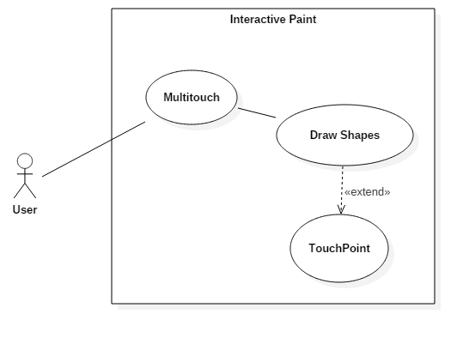

## **Sequence Diagram**

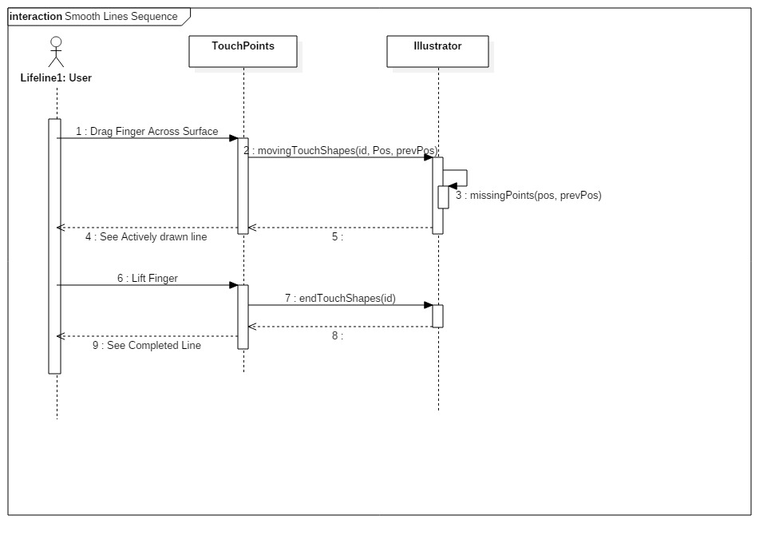

## 

## **Class Diagram**

## C:\Users\IEatR\Pictures\Smooth Lines Class.png

## **Unit Test**

Sunny Day Tests

Test Case: Draw in a circle pattern

Test Purpose:

Ensure the lines aren’t broken and are ‘smooth’

Test Setup:

1. Increase line size by pressing ‘x’ 5 times.
2. Drag your finger on the multitouch in a circular pattern

Test Output:

Lines were smooth and not ‘broken’ up (No breaks in the lines).

Expected Output:

The lines you create should not be broken up, they should be smooth and connected to itself.

## **Integration Test**

Works with all ‘Points’ shapes.

Works with all colors

Works with leap draw

Works with real sense draw

Works with multitouch draw.

## 

## **User Guide**

You can draw smooth lines by dragging your finger across the multitouch surface!

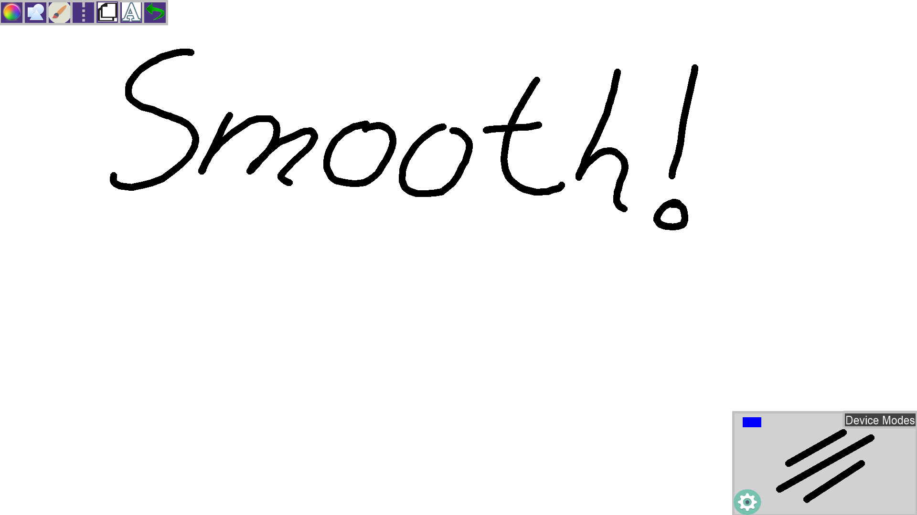

**Glossary**

N/a